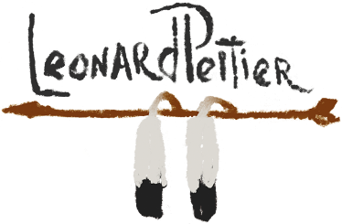
#COMEHOME Leonard Merchandise
Mi, 11. Mai 2022 16:27
#COMEHOME LEONARD
Leonard has been receiving powerful endorsements from Washington including Senator Patrick Leahy of VT. Senator Leahy has written to President urging him to "commute Leonard Peltier's prison sentence and release him from federal prison."

Leonard has been receiving powerful endorsements from Washington including Senator Patrick Leahy of VT. Senator Leahy has written to President urging him to "commute Leonard Peltier's prison sentence and release him from federal prison."
Join Our Campaign and Help Leonard #ComeHome!
Show Your Support
Follow @peltierhq on Twitter and tweet us a photo of your shirt, or any Leonard merch with the hashtag #comehome

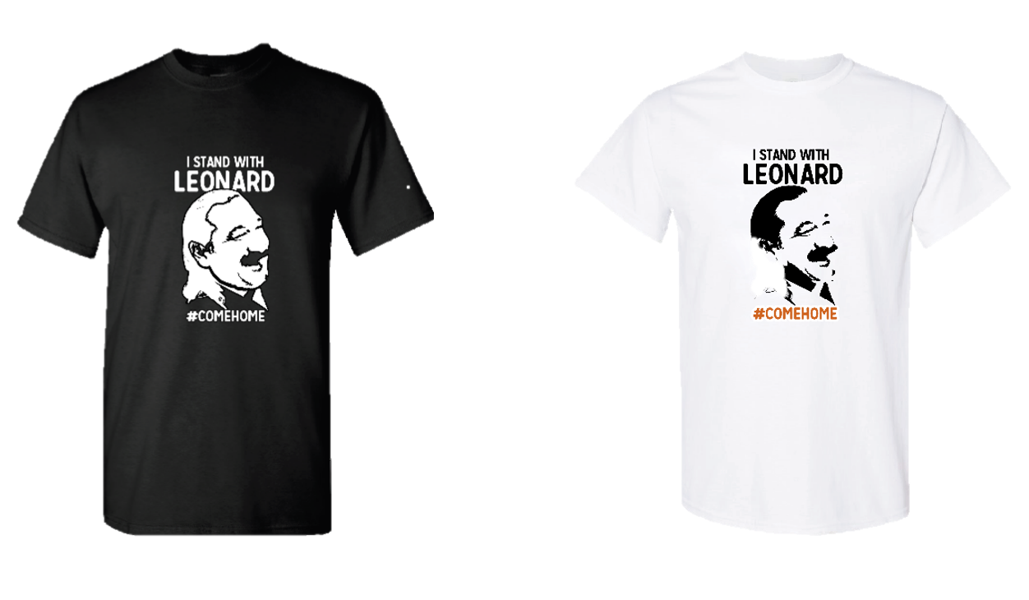
…und mehr unter: https://www.leonardpeltierstore.com/?mc_cid=de1581cc85&mc_eid=52e4639de2
This week, the Huffington Post published an article titled "The FBI Says It Still Opposes Leonard Peltier's Freedom. Its Argument Is Full Of Holes"
HuffPost has been following the wrongful imprisonment of Leonard for months, and the editors reached out to the Office of the Pardon Attorney to see if there is any movement within the case. The FBI responded with the below:
The FBI remains resolute against the commutation of Leonard Peltier’s sentence for murdering FBI Special Agents Jack Coler and Ronald Williams at South Dakota’s Pine Ridge Indian Reservation in 1975. We must never forget or put aside that Peltier intentionally and mercilessly murdered these two young men and has never expressed remorse for his ruthless actions (Bendery, 2022).
This response had been surprising to the HuffPOST, as they did not think they would get a response. The opposition from the FBI to reconsider Leonard is in fact, the biggest obstacle between Leonard and his freedom.
Our mailing address is:
Green Light Development
71 Navesink Avenue
Rumson, New Jersey 07760

